CI/CD with EKS:

1. Create Ec2 machine and allow 8080 port in security group inbound rules.
2. Login to ec2 machine though putty.
3. install git, java8, maven, Jenkins, docker.

a). Git installation:

* sudo su
* yum install git -y
* git –version

b). Java8 installation:

* yum install -y java-1.8.0-openjdk-devel.x86_64
* java -version

c). maven installation. (I have installed and setup maven manually, but by adding maven repo also we can install it, if we install by adding maven repo, it will be easy to setup maven and number of steps will be reduced)

* cd /opt/
* Wget <http://apachemirror.wuchna.com/maven/maven-3/3.6.3/binaries/apache-maven-3.6.3-bin.zip>
* unzip apache-maven-3.6.3-bin.zip
* ~/.bash_profile

export $M2_HOME=/opt/apache-maven-3.6.3/

export PATH=$PATH:/opt/apache-maven-3.6.3/bin/

* source ~/.bash_profile
* mvn -version

d). Docker installation:

* yum install docker -y
* systemctl status docker
* systemctl enable docker

e). Jenkins installation.

* tee /etc/yum.repos.d/jenkins.repo<<EOF

[jenkins]

name=Jenkins

baseurl=http://pkg.jenkins.io/redhat

gpgcheck=0

EOF

* rpm --import <https://jenkins-ci.org/redhat/jenkins-ci.org.key>
* yum install Jenkins
* systemctl start Jenkins
* systemctl status Jenkins
* systemctl enable jenkins
* open ‘http://54.145.3.68:8080/’ this url in browser and continue further steps until you see Jenkins dashboard page.
* Go to ManageJenkins > Global tool configuration and setup paths for java,maven tools.

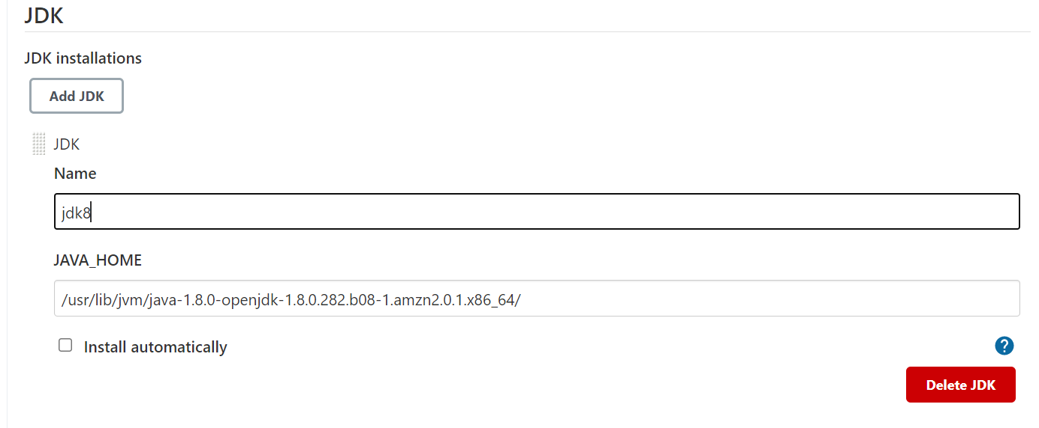

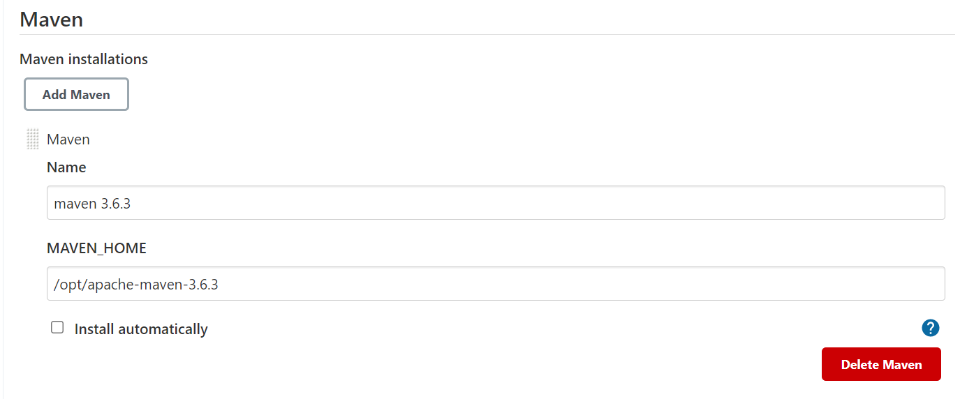

* Add Jenkins user to docker group, otherwise permission issue will come.

1. usermod -aG docker Jenkins
2. restart jenkins

* Docker, docker pipeline, Kubernetes continuous deploy plugins need to be installed on Jenkins.
* Add dockerhub credentials

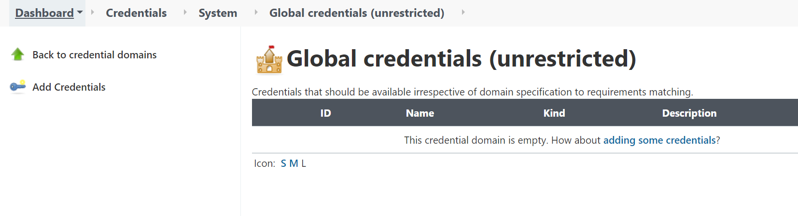

* Jenkinsfile

pipeline {

agent any

tools {

maven 'maven 3.6.3'

jdk 'jdk8'

}

environment {

registry = "abjaldevops/test"

registryCredential = 'Dockerhub'

dockerImage = ''

}

stages {

stage ('Initialize') {

steps {

sh '''

echo "PATH = ${PATH}"

echo "M2_HOME = /opt/apache-maven-3.6.3/bin/"

'''

}

}

stage('Scm Checkout'){

steps {

git 'https://github.com/abjal-devops/ci-cd.git'

}

}

stage('Build') {

steps {

sh "mvn clean install"

}

}

stage('Docker build'){

steps{

script {

dockerImage = docker.build registry + ":$BUILD_NUMBER"

}

}

}

stage('Deploy Image') {

steps{

script {

docker.withRegistry( '', registryCredential ) {

dockerImage.push()

}

}

}

}

stage('Run contianer') {

steps{

sh "docker run -d -p 80:8080 --name test $registry:$BUILD_NUMBER"

}

}

}

}